Software Requirement Specifications

AI-Based personal Diet and fitness advisor


Submitted by

Ayman Afzal

Roll No

F22NINFT1M01042

Submitted to

Mr.Muzammil u Rehman

Department of Information Technology
Faculty of Computing
The Islamia University of Bahawalpur

1. Introduction

Purpose
The purpose of this SRS is to define all functional and non-functional requirements for the “AI-Based Personal Diet and Fitness Advisor” system. This system will help users create personalized diet plans, fitness routines, calorie tracking, and health guidance using AI recommendations.

Scope
- The system allows users to:
- Create a personal health profile
- Receive AI-based diet suggestions
- Get daily/weekly workout plans
- Track calories and activities
- Monitor progress over time

The system will include login, dashboards, AI dietary recommendations, workout suggestions, and notifications.

Definitions, Acronyms
- AI – Artificial Intelligence
- User – Person using the app for diet/fitness guidance
- BMI – Body Mass Index

2. Overall Description

Product Perspective
This is a standalone mobile/web application using an AI engine to generate personalized recommendations based on the user's data.

Product Features
- User registration and login
- Health profile creation
- AI diet plan recommendation
- Personalized workout plan
- Calorie tracker
- Progress tracker (weight, workouts, calories)
- Notifications and reminders

User Classes and Characteristics
Normal User: Can create profile, view diet/workout plans, track progress
Admin: Can manage user accounts and monitor system performance

Operating Environment
- Mobile app (Android/iOS) or Web app
- Internet connection required
- Works on Chrome, Firefox, Safari browsers

3. System Features (Functional Requirements)

User Registration & Login

- User can create an account using email/password
- System verifies credentials
- System resets password on request

Health Profile Setup
- User enters age, gender, height, weight, activity level, health goals
- System calculates BMI automatically

AI-Based Diet Recommendations
- System generates diet plan based on goals (weight loss, gain, maintenance)
- Suggestions include meal timings, calories per meal, nutrient breakdown
- System updates plan daily/weekly

AI-Based Fitness Plan
- System recommends workouts based on fitness level
- Workout categories: strength, cardio, flexibility
- Provides time duration and intensity level

Calorie Tracking
- User can add foods consumed
- System tracks daily calorie intake
- Shows remaining calories for the day

Progress Tracking
- User views graphs for:
- Weight change
- Daily calorie intake
- Exercise minutes
- System sends weekly progress reports

Notifications & Reminders
- Meal reminders
- Workout reminders
- Water intake reminders

4. Non-Functional Requirements

Performance Requirements
- The system should respond within 2–3 seconds
- Dashboard should load smoothly

Security Requirements
- User passwords must be encrypted
- Only authenticated users can access personal data
- Admin has restricted access

Usability Requirements
- Simple, clean, and user-friendly UI
- Easy navigation for beginners

Reliability
- System should work 24/7
- Daily backup required

Maintainability
- Code should be modular
- AI model should support updates

5. Constraints
- Requires stable internet
- Accuracy depends on AI training data
- Mobile sensors (optional) may affect fitness tracking

6. Assumptions
- Users will enter accurate personal data
- Users have basic knowledge of diet and fitness terms

7. UML Diagrams (Optional) 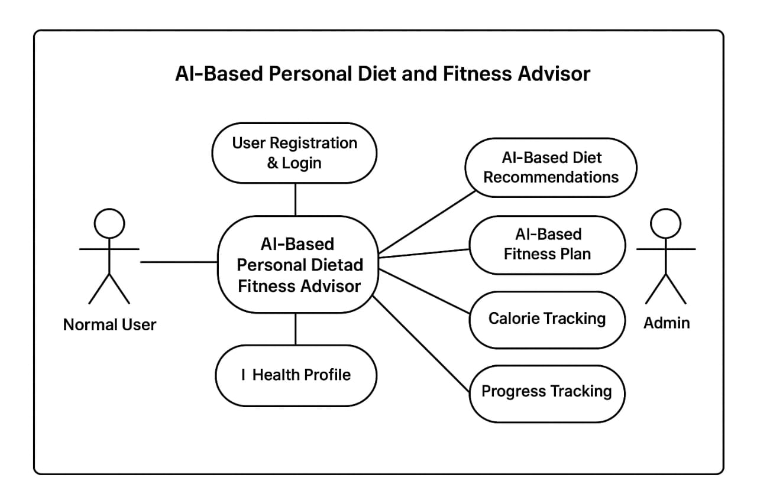

Conclusion
This SRS document defines the complete requirements for the “AI-Based Personal Diet and Fitness Advisor.” The system will provide personalized diet and fitness plans using AI to help users achieve their health goals efficiently.

